Create database pizzahut:

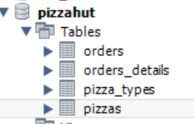

create table orders

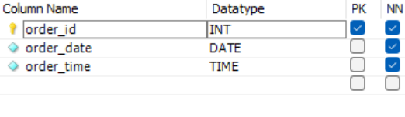 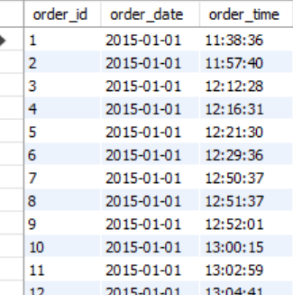

create table orders_details

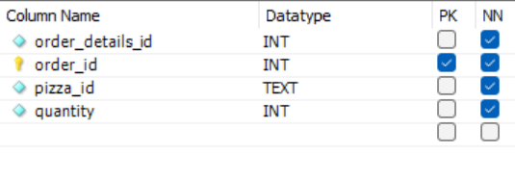

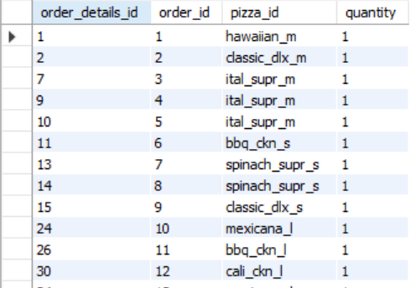

create table pizza_types

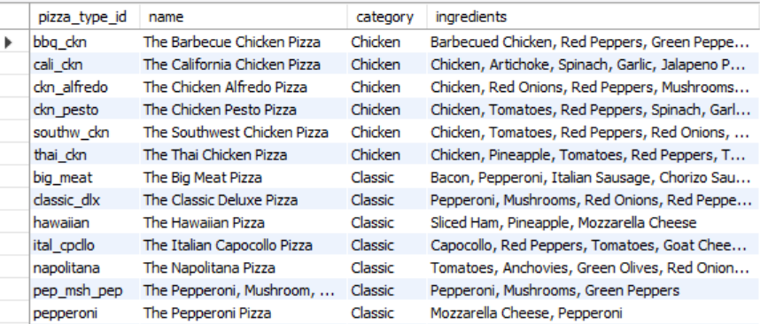

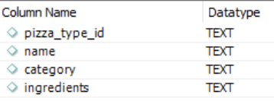

**-- 1 Retrieve the total number of orders placed**

**SELECT**

**COUNT(order_id) AS total_order**

**FROM**

**orders;**

**OUTPUT :**

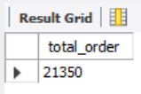

-- 2 **Calculate the total revenue generated from pizza sales**

S**ELECT**

**ROUND(SUM(orders_details.quantity * pizzas.price),**

**2) AS Total_sales**

**FROM**

**orders_details**

**JOIN**

**pizzas ON pizzas.pizza_id = orders_details.pizza_id;**

**OUTPUT :**

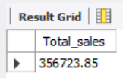

**-- 3 Identify the highest priced pizza**

**SELECT**

**pizza_types.name, pizzas.price**

**FROM**

**pizza_types**

**JOIN**

**pizzas ON pizza_types.pizza_type_id = pizzas.pizza_type_id**

**ORDER BY pizzas.price DESC**

**LIMIT 1;**

**OUTPUT:**

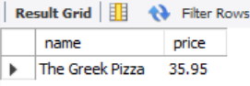

**-- 4 Identify the most common size of pizza ordered**

**SELECT**

**pizzas.size,**

**COUNT(orders_details.order_details_id) AS order_count**

**FROM**

**pizzas**

**JOIN**

**orders_details ON pizzas.pizza_id = orders_details.pizza_id**

**GROUP BY pizzas.size**

**ORDER BY order_count DESC**

**LIMIT 1;**

**OUTPUT :**

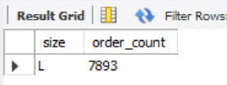

**-- 5 List the 5 topmost ordered pizza type along with their quantities**

**SELECT**

**pizza_types.name, SUM(orders_details.quantity) AS quantity**

**FROM**

**pizza_types**

**JOIN**

**pizzas ON pizza_types.pizza_type_id = pizzas.pizza_type_id**

**JOIN**

**orders_details ON orders_details.pizza_id = pizzas.pizza_id**

**GROUP BY pizza_types.name**

**ORDER BY quantity DESC**

**LIMIT 5;**

**OUTPUT :**

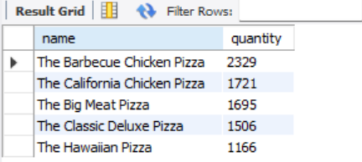

**-- 6 Join the necessary tables to find the total quantity of each pizza category ordered.**

**SELECT**

**pizza_types.category,**

**SUM(orders_details.quantity) AS quantity**

**FROM**

**pizza_types**

**JOIN**

**pizzas ON pizza_types.pizza_type_id = pizzas.pizza_type_id**

**JOIN**

**orders_details ON orders_details.pizza_id = pizzas.pizza_id**

**GROUP BY pizza_types.category**

**ORDER BY quantity DESC ;**

**OUTPUT:**

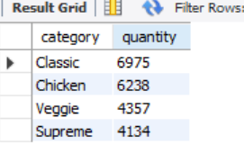

**-- 7 Determine the distribution of orders by hours of the day.**

**SELECT**

**HOUR(order_time) AS hour, COUNT(order_id) AS order_count**

**FROM**

**orders**

**GROUP BY HOUR(order_time);**

**OUTPUT:**

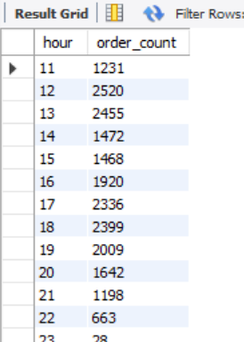

**-- 8 Join relevant tables to find the category-wise distribution of pizzas.**

**SELECT**

**category, COUNT(name)**

**FROM**

**pizza_types**

**GROUP BY category;**

**OUTPUT:**

